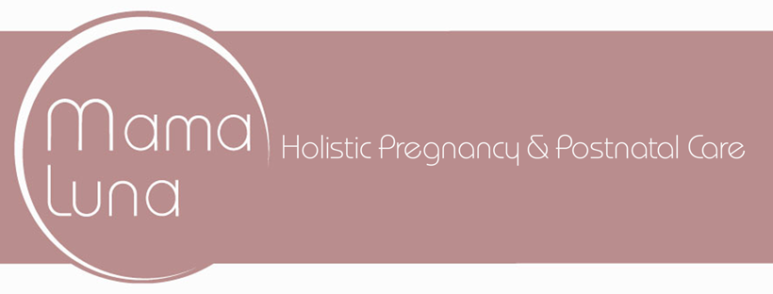
Registration Date: ________________

NEW CLIENT ANTENATAL QUESTIONNAIRE

Title | □ Miss | □ Ms | □ Mrs (please tick)
First Name: |  |  | Surname: |  | Date of Birth:
Address: |  |  |  |  | Postcode:
Telephone: | Mobile Home
Email Address:
Occupation:
How did you hear about us?

ABOUT YOUR PREGNANCY
How many weeks pregnant are you? |  |  |  | Due date
Planned place of birth
Have you practised yoga before?  If yes, please give more details |  | □ Yes |  | □ No
Do you suffer from:
Backache or pain?  High blood pressure?  Low blood pressure?  Headaches  Dizziness or fainting? | □ Yes □ No  □ Yes □ No  □ Yes □ No  □ Yes □ No  □ Yes □ No |  | Diabetes?  Pre-eclampsia?  Oedema (swollen limbs)?  Pubic / pelvic pain? |  | □ Yes □ No  □ Yes □ No  □ Yes □ No  □ Yes □ No
Have you undergone IVF treatment? |  | □ Yes |  | □ No

SOME FURTHER QUESTIONS ABOUT YOU
Any allergies? | □ Yes □ No | Details:
Do you take any regular medication? | □ Yes □ No | Details:
Have you had any significant medical conditions or operations (including  caesarean sections)? | □ Yes □ No | Details:
Have you had any injuries either in the past or present? | □ Yes □ No | Details:
Is this your first pregnancy? | □ Yes □ No | Details:
Have you ever had a miscarriage? | □ Yes □ No | Details:

All information provided is confidential and will not be passed on to third parties. Before undertaking any classes with MamaLuna, please consult your midwife or GP.

Classes, Terms and Conditions and Consent

I agree to the Terms and Conditions of MamaLuna as set out on the MamaLuna website.

I explicitly consent to you creating and storing medical records concerning my treatment, which may include details concerning my medication, treatment and other issues affecting my health conditions, in accordance with the General Data Protection Regulation (GDPR). I understand that these records will be processed in accordance with the MamaLuna Privacy Policy, which is set out on the MamaLuna website.

I have read and understood the above information and agree to give my explicit consent.

Signed: ________________________________________ Date: ____________________

Name (PRINT): __________________________________

Promotional Information

For the purposes of promoting healthcare including offers and advice, MamaLuna would also like to stay in touch with you with information that we feel could be of interest to you and beneficial to your general well-being. For these purposes, please indicate below if you consent to joining our email list:

□ Yes please □ No thanks

Signed: ________________________________________ Date: _________________

